# CS 255 System Design Document Template

This template lays out all the different sections that you need to complete for Project Two. Each section has guidance to prompt your thinking. You will need to continually reference the interview transcript as you work to make sure that you are addressing your client’s needs. There is no required length for the final document. Instead the goal is to complete each section based on what your client’s needs are. Remove this note when you are finished, and replace all bracketed text with the relevant information.

## UML Diagrams

### UML Use Case Diagram

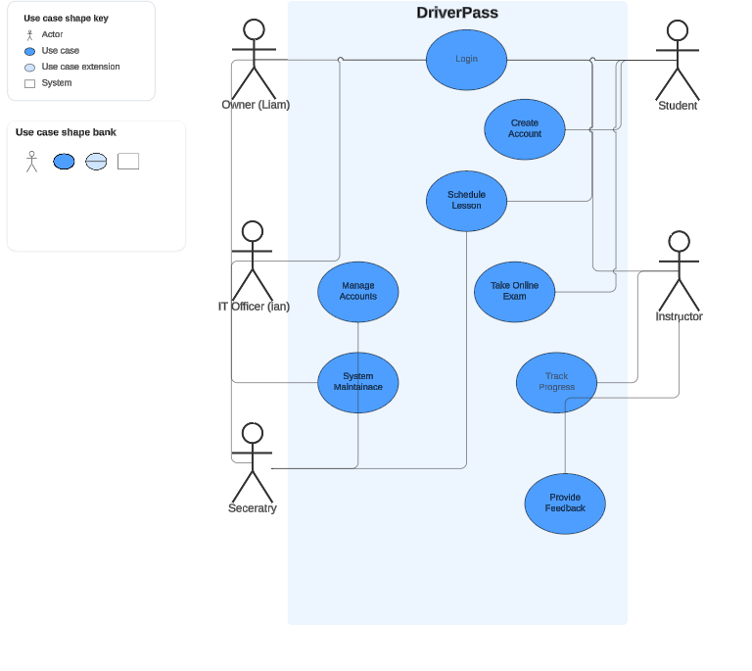

### UML Activity Diagrams

### UML Sequence Diagram

### UML Class Diagram

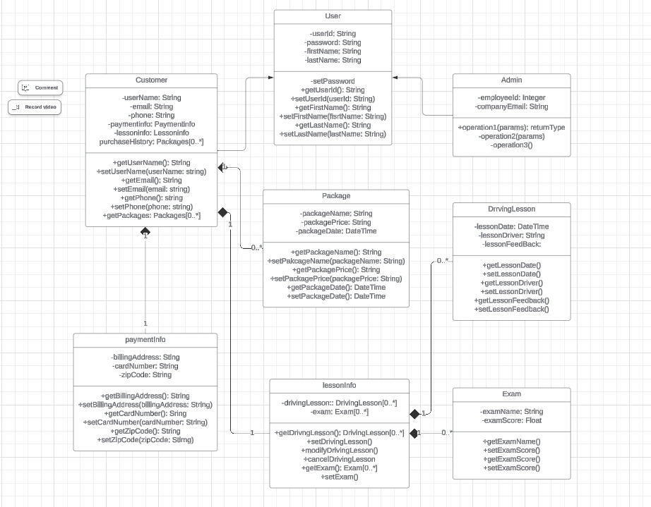

## Technical Requirements

Technical requirements for my system design are shown below:

* Hardware
  + Linux cloud servers serving various browser clients
  + Client devices running a modern web browser
    - Smart phone
    - Tablet
    - Laptop
    - Desktop
* Software
  + Latest security suites integration
  + Web-based distributed system, running on the Linux operating system
  + Supported browsers include:
    - Chrome
    - Edge
    - Firefox
    - Safari
  + Platform-agnostic: Will work on client devices running Mac, Linux and Windows operating systems
* Tools
  + Lucidchart models for the following:
    - UML Use Case diagram
    - UML Activity diagram for each use case
    - UML Sequence diagram for each activity
    - UML Class diagram for the entire system
  + Development environments (laptops/desktops and monitors)
  + Current IDE for development
    - Eclipse
    - Visual Studio
* Infrastructure (needed for optimal system performance/delivery to client device)
  + High-speed Internet connection
    - Hardwire (ethernet)
    - WiFi
    - 4g/5g